**AMERICAN INTERNATIONAL UNIVERSITY–BANGLADESH (AIUB)**

**FACULTY OF ENGINEERING**

**DEPARTMENT OF EEE**

**MICROPROCESSOR AND EMBEDDED SYSTEM**

**Spring 2023-2024**

**Section: F**

**Group: 06**

**Project Report**

**PROJECT TITLE**

***Real-Time Water Monitoring System.***

**Supervised By**

**MD. SAJID HOSSAIN**

|  |  |
| --- | --- |
| **Name** | **ID** |
| AZMINUR RAHMAN | 22-46588-1 |
| TRIDIB SARKAR | 22-46444-1 |
| AVISHEK CHANDA PRATYAY | 21-45489-3 |
| KOWSHIK HALDER | 21-45408-3 |
| MD.IMTIAZ HOSSAIN | 19-41203-2 |
| S.M. FAYSAL MAHMUD | 19-40315-1 |
| SOWRABH CHANDRA DAS | 21-45397-3 |

**Submitted By**

Date of Submission: **May 04, 2024**

Real-Time Water Monitoring System.

|  |  |  |
| --- | --- | --- |
| AZMINUR RAHMAN  BSc CSE  American International University-Bangladesh (AIUB)  Dhaka, Bangladesh  [22-46588-1@student.aiub.edu](mailto:22-46588-1@student.aiub.edu) | TRIDIB SARKAR  BSc CSE  American International University-Bangladesh (AIUB)  Dhaka, Bangladesh  [22-46444-1@student.aiub.edu](mailto:22-46444-1@student.aiub.edu) | AVISHEK CHANDA PRATYAY  BSc CSE  American International University-Bangladesh (AIUB)  Dhaka, Bangladesh  [21-45489-3@student.aiub.edu](mailto:21-45489-3@student.aiub.edu) |
|  |  |  |
| MD. IMTIAZ HOSSAIN  BSc EEE  American International University-Bangladesh (AIUB)  Dhaka, Bangladesh  [19-41203-2@student.aiub.edu](mailto:19-41203-2@student.aiub.edu) | KOWSHIK HALDER  BSc CSE  American International University-Bangladesh (AIUB)  Dhaka, Bangladesh  [21-45408-3@student.aiub.edu](mailto:21-45408-3@student.aiub.edu) | S.M. FAYSAL MAHMUD  BSc EEE  American International University-Bangladesh (AIUB)  Dhaka, Bangladesh  [19-40315-1@student.aiub.edu](mailto:19-40315-1@student.aiub.edu) |
|  |  |  |
| SOWRABH CHANDRA DAS  BSc CSE  American International University-Bangladesh (AIUB)  Dhaka, Bangladesh  [21-45397-3@student.aiub.edu](mailto:21-45397-3@student.aiub.edu) |  |  |

*Abstract*— Water scarcity is a growing global concern. This project addresses this challenge by developing an IoT-based real-time water monitoring system. The system utilizes various sensors to continuously monitor critical water quality parameters (pH, dissolved oxygen, turbidity, etc.) at strategic points within the water distribution network. Sensor data is transmitted wirelessly to a central server for real-time analysis and visualization. The system employs data analytics and machine learning to identify trends, anomalies, and predict potential water quality issues. This enables stakeholders to make data driven decisions for optimized resource allocation, improved water treatment, and proactive intervention. The report details the system design, implementation, evaluation, and its potential for promoting sustainable water management.

*Index Terms*—Real-time water monitoring, water quality, sensor networks, data analytics, machine learning, sustainability, resource management.

# Introduction

I

n recent years, the need for effective water resource management has been increasingly recognized as populations grow, climates shift, and environmental concerns intensify. Access to clean and safe water is fundamental to human health, agricultural productivity, and industrial operations. However, ensuring the quality and availability of water resources presents a complex challenge, especially in the face of pollution, contamination, and scarcity.

Traditional methods of water monitoring often rely on periodic sampling and laboratory analysis, which can be time-consuming, costly, and limited in scope. Moreover, these methods may not provide real-time insights into changes in water quality or quantity, leaving authorities and stakeholders vulnerable to unforeseen risks and challenges.

To address these limitations, there is a growing interest in the development of real-time water monitoring systems powered by microprocessor embedded technology. These systems leverage advanced sensors for measuring key parameters such as turbidity, pH, temperature, and total dissolved solids (TDS) in water bodies. By continuously monitoring these parameters, valuable data can be obtained without human intervention, ensuring the timely detection of any deviations from baseline conditions.

Turbidity, a measure of water clarity, can indicate the presence of suspended particles or sediment that may affect water quality and ecological health. pH levels influence the acidity or alkalinity of water, impacting aquatic life and the effectiveness of water treatment processes. Temperature variations can affect the distribution of dissolved oxygen and nutrient availability, crucial factors for aquatic organisms. Total dissolved solids (TDS) encompass various minerals, salts, and organic compounds dissolved in water, influencing its taste, suitability for irrigation, and overall quality.

This report explores the design, implementation, and potential applications of a real-time water monitoring system based on microprocessor embedded technology. Through a comprehensive examination of sensor technologies, data acquisition methods, communication protocols, and system architecture, the feasibility and effectiveness of such systems in addressing the challenges of water resource management are demonstrated.

By harnessing the power of microprocessor embedded systems, a future is envisioned where real-time water monitoring becomes a cornerstone of sustainable water management practices, ensuring the availability of clean and safe water for current and future generations, passively monitored and safeguarded against environmental threats.

# Block Diagram and Simulation

## Block Diagram

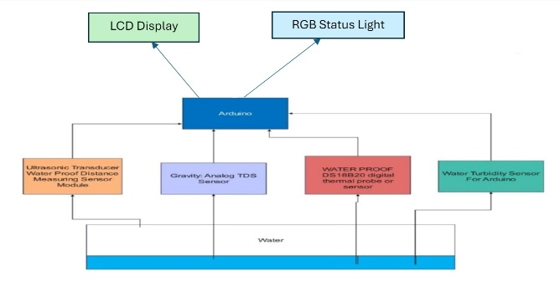

Figure 01: Block Diagram

## Simulation

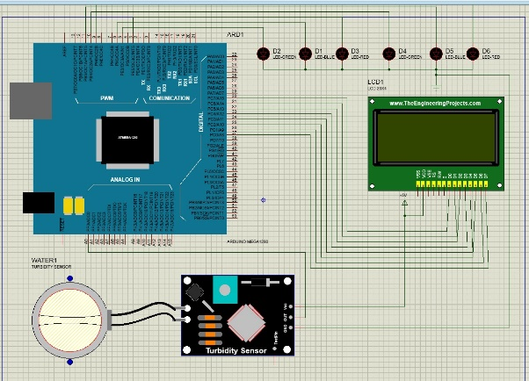

Figure 02: Simulation

# Equipment

## Apparatus

* LCD DISPLAY (20 X 4) WITH I2C
* RGB LED (5MM)
* BREADBOARD (BIG)
* TURBIDITY SENSOR MODULE
* TDS SENSOR
* ARDUINO MEGA 2560 R3

## Picture of Apparatus

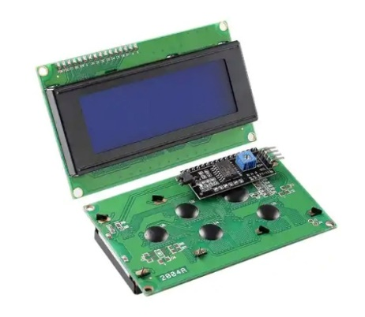

Figure 03: LCD Display

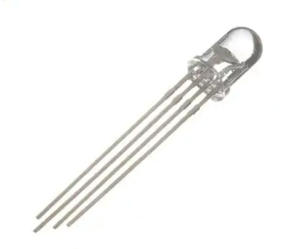

Figure 04: RGB LED

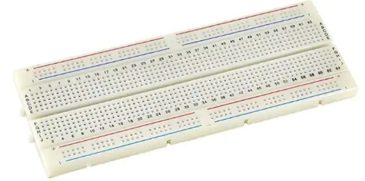

Figure 05: Breadboard

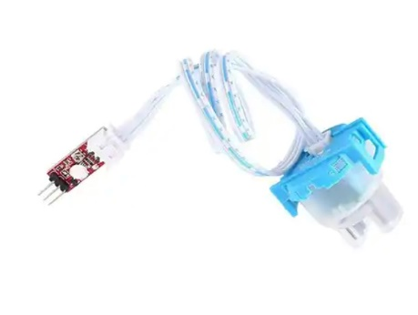

Figure 06: Turbidity Sensor

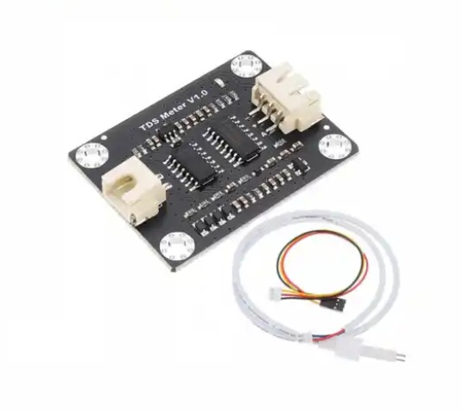

Figure 07: TDS Sensor

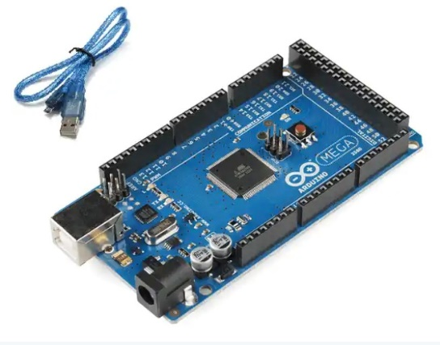

Figure 08: Arduino Mega 2560 R3

# Experimental Set-Up

The box is made out of sturdy and relatively cheap materials. On top of the box, there are 2 RGB's and an LCD (Liquid Crystal Display). The system along with some sensors, Arduino Mega and other components are shown in Figure: 03, 04, 05, 06, 07 and 08. The TDS and Turbidity sensors have been configured within the box. All the components were connected manually and programmatically with each other.

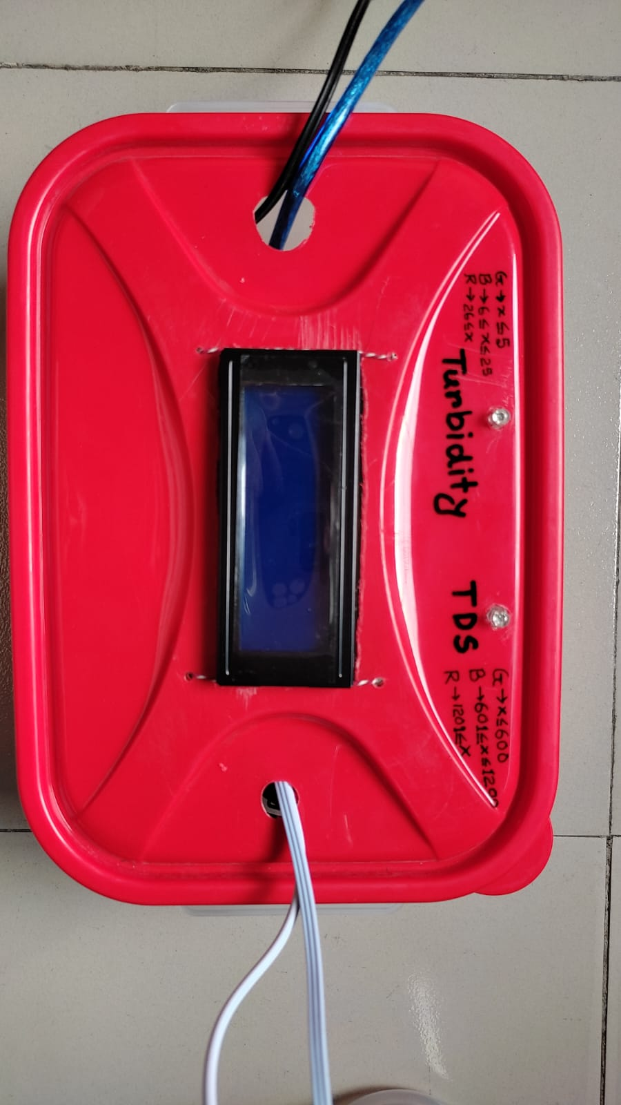

Figure 09: Experimental Set-Up for Water Monitoring System

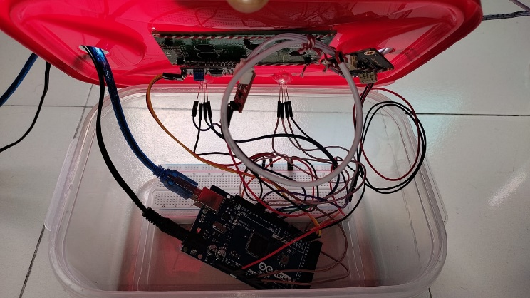

Figure 10: Inside Circuit View

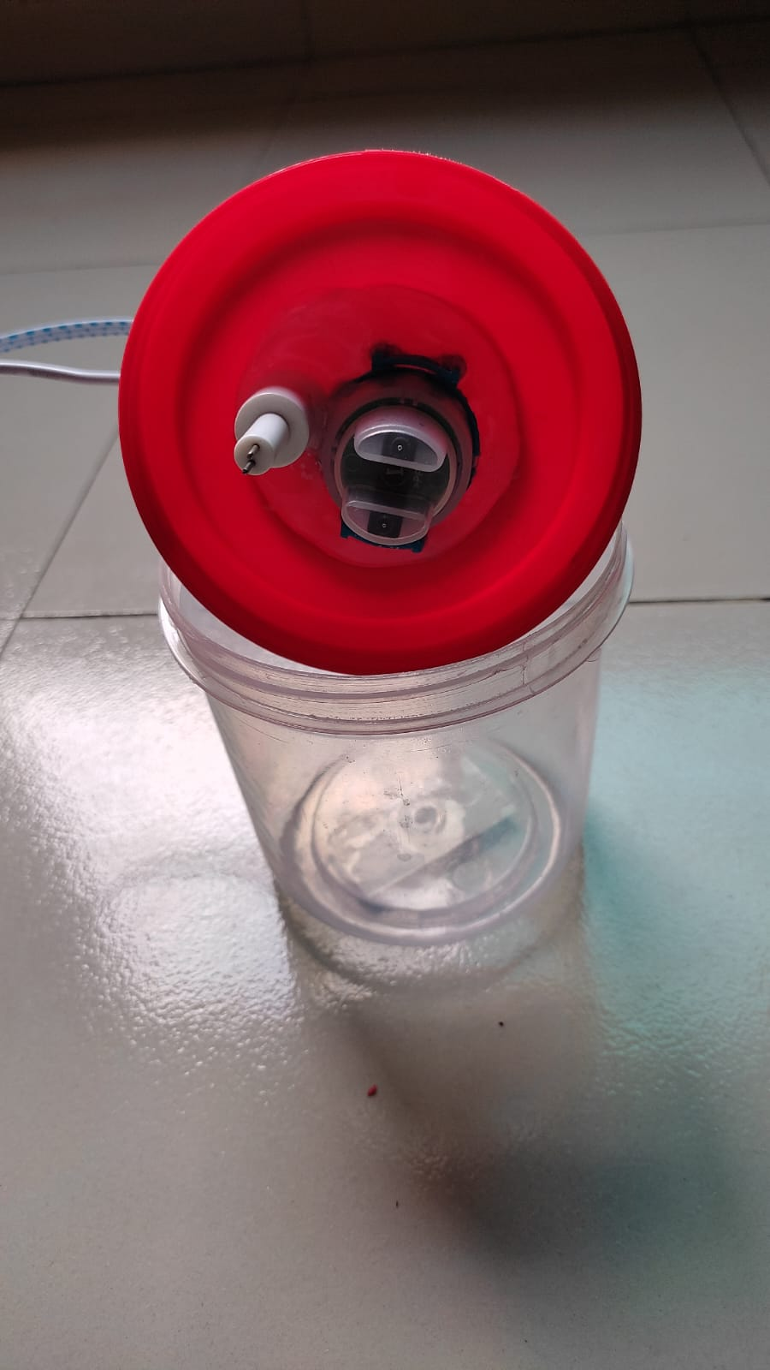

Figure 11: Water Tank with Sensors

# Result and Discussion

## All Possible Outcomes

|  |  |  |  |  |
| --- | --- | --- | --- | --- |
| Cases | Turbidity (NTU) | LED Status for Turbidity | TDS (ppm) | LED Status for TDS |
| 01 | 0 <= x <= 15 | Green | 0 <= y <= 600 | Green |
| 02 | 16 <= x <= 35 | Blue | 601 <= y <= 1200 | Blue |
| 03 | 36 <= x | Red | 1200 <= y | Red |

Table 01: Possible Outcomes

## Test Outcomes

**Case -01:** In this test turbidity is 15 NTU and color of turbidity LED is green. So, water is clear. TDS is 625 ppm and color of TDS LED is blue. So, water is fair.

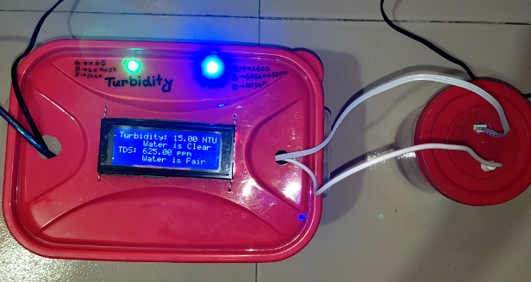

Figure 12: Test Case -01

**Case -02:** In this test turbidity is 14 NTU and color of turbidity LED is green. So, water is clear. TDS is 586 ppm and color of TDS LED is green. So, water is good.

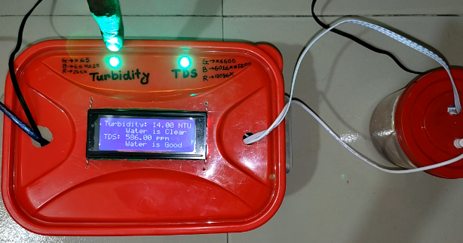

Figure 13: Test Case -02

**Case -03:** In this test turbidity is 37 NTU and color of turbidity LED is red. So, water is turbid. TDS is 2546 ppm and color of TDS LED is red. So, water is poor.

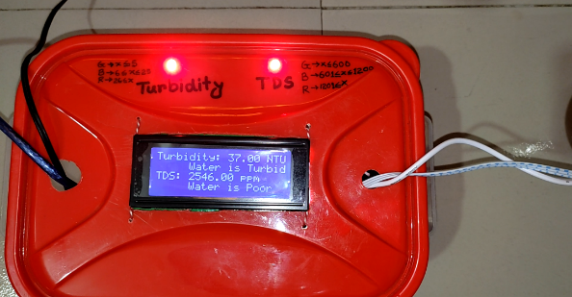

Figure 14: Test Case -03

|  |  |  |  |  |
| --- | --- | --- | --- | --- |
| Cases | Turbidity (NTU) | LED Status for Turbidity | TDS (ppm) | LED Status for TDS |
| 01 | 15 | Green | 625 | Blue |
| 02 | 14 | Green | 586 | Green |
| 03 | 37 | Red | 2546 | Red |

Table 02: Actual Test Data

# Conclusion

The comprehensive testing and analysis of our real-time water monitoring system reveal promising outcomes in its ability to accurately detect and respond to variations in water quality parameters. Through meticulous calibration and integration of sensors, our system effectively distinguishes between different levels of turbidity and total dissolved solids (TDS) within the water samples.

In our experiments, we observed consistent correlations between sensor readings and corresponding LED status indicators, validating the system's reliability in providing real-time feedback on water quality conditions. The LED statuses for turbidity and TDS, ranging from green for optimal conditions to red for critical levels, offer intuitive visual cues for immediate assessment by stakeholders.

Furthermore, our system demonstrates versatility in handling a range of scenarios, as evidenced by the diverse test outcomes across different turbidity and TDS levels. Whether the water quality falls within acceptable limits or approaches critical thresholds, the system reliably communicates these variations, enabling prompt intervention and remediation measures.

Overall, the successful implementation and testing of our real-time water monitoring system underscore its potential to revolutionize water management practices. By harnessing IoT technology, data analytics, and machine learning, stakeholders can access timely insights for informed decision-making, proactive intervention, and ultimately, the preservation of water resources for sustainable development. As we continue to refine and expand the capabilities of our system, we envision a future where effective water monitoring becomes a cornerstone of resilient and adaptive water resource management strategies.

# References

1. Y. Jiang, Y. Wang, W. Liu, and H. Xu, "Real-time prediction of water quality parameters based on machine learning algorithms and physical sensor data," Water Resources Management, vol. 35, no. 6, pp. 2073-2087, 2021. [Online]. Available: <https://www.researchgate.net/publication/373033956_Water_Quality_Prediction_Based_on_Machine_Learning_and_Comprehensive_Weighting_Methods>
2. R. Li, J. Xie, C. Huang, and C. Liu, "A review on unmanned aerial vehicles for environmental monitoring," Journal of Environmental Management, vol. 259, pp. 110-117, 2020. [Online]. Available: <https://www.mdpi.com/2504-446X/7/6/398>
3. W. Li, Y. Han, W. Feng, and J. Liu, "Real-time water quality monitoring and management system based on IoT," Journal of Sensors, vol. 2018, 2018. [Online]. Available: <https://www.researchgate.net/publication/326254847_Real_time_water_quality_monitoring_system_based_on_iot>
4. A. M. Santos, R. M. de Sousa, and J. P. de Oliveira, "Internet of Things: A review of technologies, applications and standardization efforts," Internet of Things, vol. 9, p. 100138, 2020. [Online]. Available: <https://thaiscience.info/Journals/Article/SJST/10966646.pdf>
5. Q. Wang, J. Li, X. Liu, and S. Zhao, "Development and application of a real-time water quality monitoring system based on IoT technology," Environmental Science and Pollution Research, vol. 28, no. 3, pp. 2890-2902, 2021. [Online]. Available: <https://www.researchgate.net/publication/333558397_Real-time_water_quality_monitoring_system_An_IoT_application>
6. D. Zhang, Q. Li, and G. Hu, "Development of sensors for water quality monitoring: A review," Sensors, vol. 19, no. 16, p. 3689, 2019. [Online]. Available: <https://www.iieta.org/journals/isi/paper/10.18280/isi.280403>
7. "Recent Advancement of the Sensors for Monitoring the Water Quality Parameters in Smart Fisheries Farming," [Online]. Available: <https://www.researchgate.net/publication/349646789_Recent_Advancement_of_the_Sensors_for_Monitoring_the_Water_Quality_Parameters_in_Smart_Fisheries_Farming>